Start at A

Step 1:
B: 2
C: 35
D: 10
Shortest distance is B (A>B), go there.
Visited : A (0)

Step 2:
D: min( 10,[2+3]) = 5
E: 2+ 4 = 6
F = 2 + 13 = 15
Shortest distance is D (A >B >D), go there
Visited: A(0), B(2)

Step 3:
C: min([5 + 20],35) = 25
G: 5 + 22 = 27
F: 5 + 24 = 29
H: 5 + 11 = 16
Shortest distance is E( A> B > E), go there
Visited A(0), B(2), D(5)

Step 4:
H: min([6+8], 16) = 14
F: min([6+12], 29) = 18
Shortest distance is H (A>B>E>H), go there
Visited A(0), B(2), D(5), E(6)

Step 5:
F: min([14+5,], 18) = 18
G: min([14+16],27) = 27
Shortest distance is F(A>B>E>F), go there
Visited A(0), B(2), D(5), E(6), H(14)

Step 6:
F isn’t connected to any unvisited verticies
Shortest distance is C, go there (A > B > D >C)
Visited A(0), B(2), D(5), E(6), H(14), F(18)

Step 7:
G: min([25 + 15], 27) = 27
Last remaining is G(A>B>D>G), go there
Visited A(0), B(2), D(5), E(6), H(14), F(18), C(25)

Step 8:
No remaining verticies
Visited A(0), B(2), D(5), E(6), H(14), F(18), C(25), G(27)

Shortest distances:
A – 0
B - 2 (A > B)
C- 25 (A > B > D > C)
D – 5 (A > B > D)
E - 6 (A > B > E)
F – 18 (A > B > E > F)
G – 27 (A > B > D > G)
H – 14 (A > B > E > H)

Problem 5:
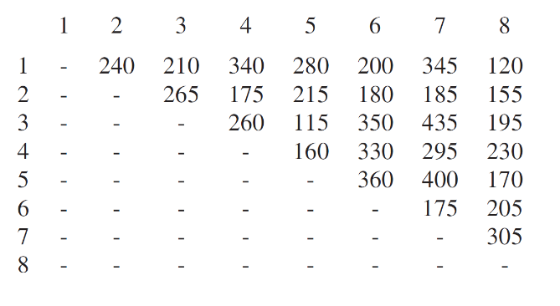
Cheapest bridge is 115, start there, and keep adding the cheapest bridge that won’t complete a cycle.
115 (3 > 5)
115, 120 (3 >5) (1 > 8)
115, 120, 155 (3 > 5) (1 > 8 > 2)
115, 120, 155, 160 (3 > 5 > 4) (1 > 8 > 2)
115, 120, 155, 160 ,170 (3 > 5) (5 > 4) (5>8) (8>1) (8 > 2)

